III B. Tech I Semester Supplementary Examinations – July, 2024
DIGITAL IMAGE PROCESSING
Time: 150 Min (CSE) Max. Marks:80M

SECTION – A
Answer all Four questions 4×10M=40M

1 | a. | Define Digital Image Processing. Explain the fundamental Steps in Digital Image Processing with a neat block diagram.
1 | b. | Compute the Euclidean Distance (D1), City-block Distance (D2) and Chessboard distance (D3) for points p and q, where p and q be (5, 2) and (1, 5) respectively. Give answer in the form (D1, D2, D3).
1 | c. | What is the role of sampling and quantization in Digital Image processing? Design an algorithm for Image sampling and quantization.
2 | a. | What is noise PDF. Explain Erlang and Impulse noise. What is the difference between Gaussian noise and impulse noise.
2 | b. | Given a 3x3 image matrix:  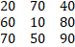  Add Rayleigh noise with a scale parameter b of 5. After computations, write the output matrix.
2 | c. | Design an algorithm to add salt and pepper noise in a real image. After that apply suitable image filtering technique to restore the image again.
3 | a. | What is Image Segmentation? Why do we need Image Segmentation?
3 | b. | Consider the following binary image and find the resultant image by applying  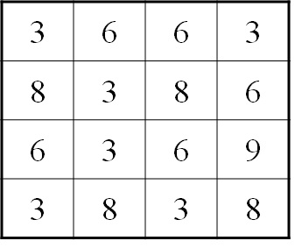  - Gradient Operator  - Laplacian Operator
3 | c. | Design and implement a segmentation algorithm for an Image to detect  - Point and line detection  - Horizontal and vertical edge detection separately  - Also obtain the absolute magnitude of gradient and orientation of gradient
4 | a. | What is the role of image compression and decompression in digital image processing? Differentiate the different types of image compression techniques and the image formats.
4 | b. | Characterize the working of Golomb Coding in Advanced Image Compression with an example and describe the benefits and drawbacks of Golomb coding.
4 | c. | A networking company uses a compression technique to encode the message before transmitting over the network. Suppose the message contains the following characters with their frequency:  - If the compression technique used is Huffman Coding, how many bits will be saved in the message?  - Design the compression and decompression algorithm for Huffman Coding
  Character | frequency
  A | 9
  B | 3
  C | 4
  D | 7
  E | 5

SECTION - B
Answer all Two questions 2×20M=40M
5 | a. | What is Morphological Image Processing. Illustrate the Erosion and Dilation process by taking a sample image matrix.
5 | b. | One black and white Image has been given along with the mask. Apply the mask as a structuring element and perform the flowing operations  (i)hit-or-miss transformation (ii) opening (iii) Closing (iv) Thickening  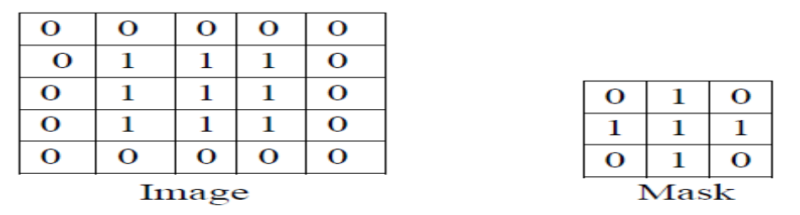
5 | c. | Design an algorithm for Boundary Extraction in binary image processing. How can morphological process applied to extract the connected binary components, and what considerations are important in choosing the structuring element?
6 | a. | Explain basic steps for filtering of image in Spatial domain. Discuss various type of Transformation techniques for image enhancement.
6 | b. | What is histogram of an Image. How histogram equalization used in Image enhancement process? Consider the given binary image  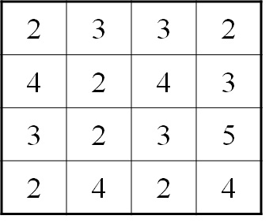  - Draw the histogram curve  - Calculate histogram equalization  - Find the contrast stretching through histogram
6 | c. | What are the various filters used for removing noise in Spatial domain? Design an algorithm for smoothing and sharpening of an image using two different filters and differentiate each filter performance mathematically.

